Jahangirnagar University (JU)



# Institute of Information Technology

**Lab Report-1**

Assembly Language

**Name. Md Shakil Hossain Class Roll. 2023**

## Experiment 1.

**Title. Addition of two 8-bit numbers.**

**Algorithm.**

Addition of two 8-bit numbers:

1. Input data from user to register AL (first number)
2. Move the first number from register AL to register BL.
3. Input data from user to register AL (second number)
4. Move the second number from register AL to register BH.
5. Add these two numbers (contents of register BL and register BH; store in register BL)
6. Subtract 48 from register BL
7. Store the result form register BL to register DL
8. Print
9. Stop

## Flow chart.

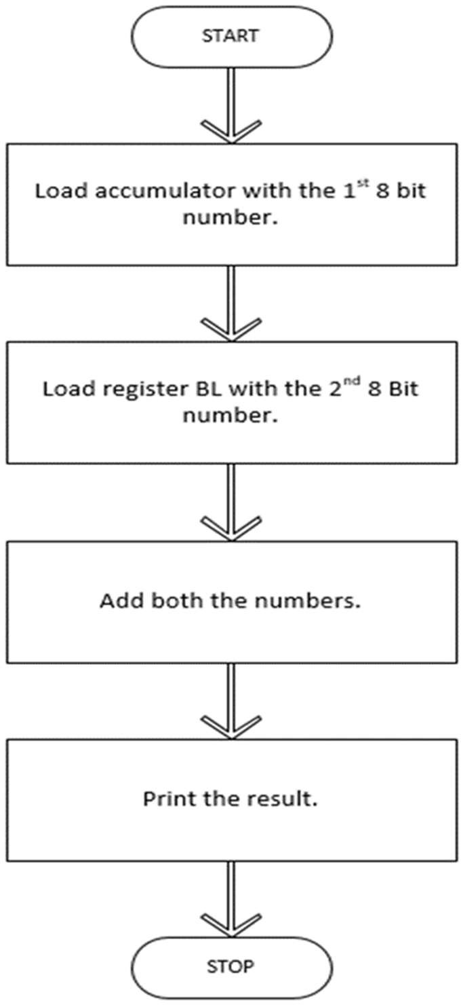

**Program Source Code.**

org 100h

.data

a db 0ah,0dh,"enter 1st no :$" b db 0ah,0dh,"enter 2nd no :$"

c db 0ah,0dh,"Adding two numbers :$"

.code

mov ax,@data mov ds,ax

;input first number lea dx,a

mov ah,09h int 21h

mov ah,01 int 21h lea dl,ah int 21h mov bl,al

;input second number lea dx,b

mov ah,09h int 21h

mov ah,01 int 21h lea dl,ah int 21h mov bh,al

sub bh,30h sub bl,30h

;third number lea dx,c

mov ah,09h int 21h

add bh,bl add bh,30h mov dl,bh

mov ah,02

int 21h

ret

## Sample input & output:

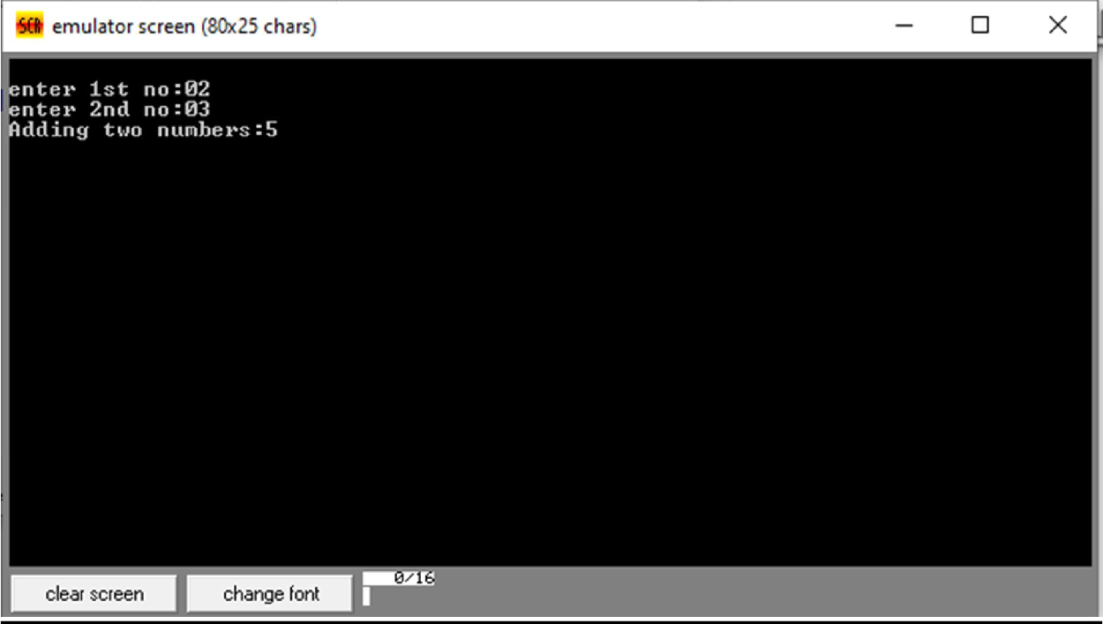

**Experiment 2.**

**Title. Subtraction of two 8-bit numbers.**

**Algorithm.**

1. Input data from user to register AL (first number)
2. Move the first number from register AL to register BL.
3. Input data from user to register AL (second number)
4. Move the second number from register AL to register BH.
5. Subtract these two numbers (contents of register BL and register BH; store in register BL)
6. Add 48 from register BL
7. Store the result form register BL to register DL
8. Print
9. Stop

## Flow chart.

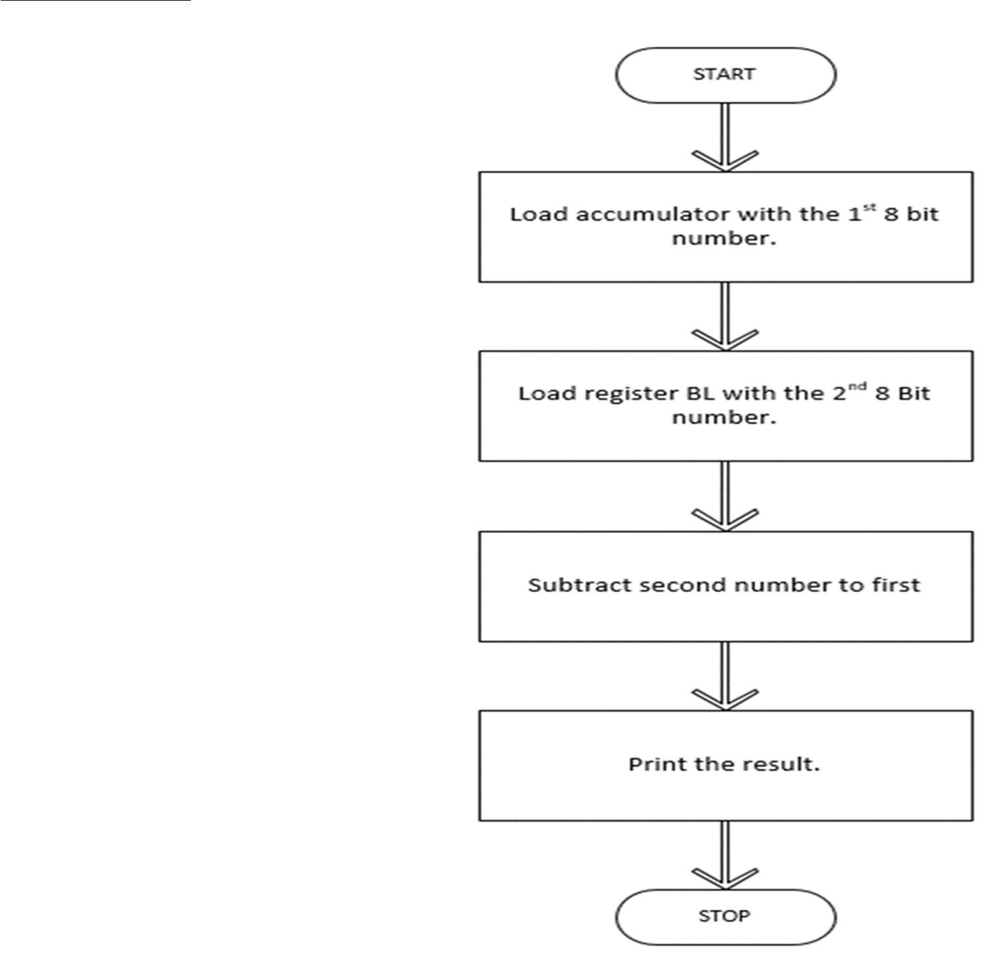

**Program Source Code.**

org 100h

.data

a db 0ah,0dh,"enter 1st no :$" b db 0ah,0dh,"enter 2nd no :$"

c db 0ah,0dh,"Subtracing two numbers :$"

.code

mov ax,@data mov ds,ax

;input first number lea dx,a

mov ah,09h int 21h

mov ah,01

int 21h lea dl,ah int 21h mov bl,al

;input second number lea dx,b

mov ah,09h int 21h

mov ah,01 int 21h lea dl,ah int 21h mov bh,al

sub bh,30h sub bl,30h

;third number lea dx,c

mov ah,09h int 21h

sub bh,bl add bh,30h mov dl,bh

mov ah,02 int 21h

ret

## Sample input & output:

